University of South Bohemia in České Budějovice
Faculty of Agriculture and Technology
Department name
Bachelor/Master thesis
Title
Author: Author name
Supervisor: Name and titles
Consultant: Name and titles
České Budějovice
2021
Declaration
I declare that I am the author of this graduation thesis and that I used only sources and literature displayed in the list of references in its preparation.
In České Budějovice on
Signature
Abstrakt
Abstract in the Czech language
Klíčová slova: Keywords in the Czech language
Abstract
Text of abstract
Keywords: in English

Acknowledgment
Acknowledgment words if any

Content
Introduction 6
1 Chapter title 7
1.1 Section title 8
1.1.1 Subsection title 8
2 Chapter title 9
3 Chapter title 10
4 Discussion 11
Conclusions 12
References 13
List of figures 16
List of tables 17
List of abbreviations 18

Introduction
Lorem ipsum dolor sit amet, consectetuer adipiscing elit. Proin in tellus sit amet nibh dignissim sagittis. Nulla non lectus sed nisl molestie malesuada. Class aptent taciti sociosqu ad litora torquent per conubia nostra, per inceptos hymenaeos. Fusce tellus. Etiam dictum tincidunt diam. Duis aute irure dolor in reprehenderit in voluptate velit esse cillum dolore eu fugiat nulla pariatur. Donec vitae arcu. Praesent vitae arcu tempor neque lacinia pretium. Nulla non lectus sed nisl molestie malesuada. Etiam bibendum elit eget erat. Praesent id justo in neque elementum ultrices. Maecenas fermentum, sem in pharetra pellentesque, velit turpis volutpat ante, in pharetra metus odio a lectus. Fusce suscipit libero eget elit.
Sed ac dolor sit amet purus malesuada congue. Vivamus porttitor turpis ac leo. Morbi imperdiet, mauris ac auctor dictum, nisl ligula egestas nulla, et sollicitudin sem purus in lacus. Phasellus rhoncus. In convallis. Praesent dapibus. Integer vulputate sem a nibh rutrum consequat. Nullam faucibus mi quis velit. Etiam bibendum elit eget erat. Etiam egestas wisi a erat. Donec iaculis gravida nulla. Curabitur sagittis hendrerit ante. Aliquam id dolor. Curabitur bibendum justo non orci. Donec ipsum massa, ullamcorper in, auctor et, scelerisque sed, est. Maecenas libero. Morbi scelerisque luctus velit.

Chapter title
The author of the thesis chooses the titles of the chapters according to his needs (except for the introduction, discussion and conclusion). The author uses citations in the text to mark specific parts of the work that have been paraphrased or directly cited. Each citation in the text contains the author's surname and year of publication and is usually located at the end of the paraphrased section. Quote works as follows:
- One author: (Zelinka, 2003) or: … in the work of Zelinka (2003).
- Two authors: (Soukup and Veselý, 2007) or: …as published Soukup and Veselý (2007).
- Three and more authors: (Třináctý et al., 2013) or: …in the work of Třináctý et. al (2013).
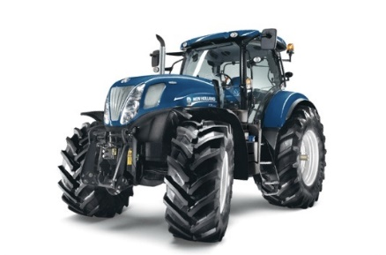
Lorem ipsum dolor sit amet, consectetuer adipiscing elit. Nam sed tellus id magna elementum tincidunt. Quis autem vel eum iure voluptate velit esse quam nihil molestiae consequatur, vel illum qui dolorem eum fugiat quo voluptas nulla pariatur?
Figure 1.1: Tractor NH2 (Hybrid.cz, 2012)
Mauris dolor felis, sagittis at, luctus sed, aliquam non, tellus. Praesent id justo in neque elementum ultrices. Maecenas aliquet accumsan leo. Nulla quis diam. Ut enim ad minim veniam, ex ea commodo consequat.
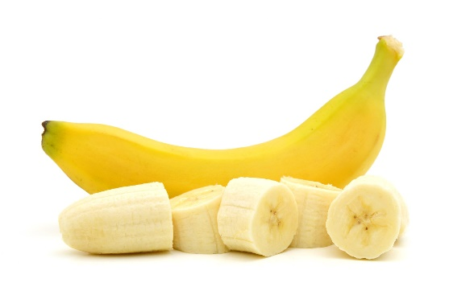
Aliquam erat volutpat. Duis risus. Phasellus faucibus molestie nisl. Cum sociis natoque penatibus et magnis dis parturient montes, nascetur ridiculus mus.
Figure 1.2: Banana

Section title

Subsection title
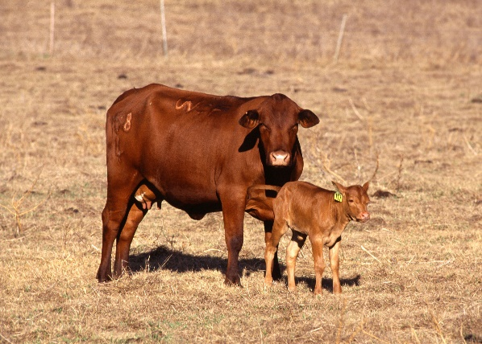
Only three levels of chapters are used in the final thesis.
Figure 1.3: Domestic tur

Chapter title
Lorem ipsum dolor sit amet, consectetuer adipiscing elit. Nam sed tellus id magna elementum tincidunt. Neque porro quisquam est, qui dolorem ipsum quia dolor sit amet, consectetur, adipisci velit, sed quia non numquam eius modi tempora incidunt ut labore et dolore magnam aliquam quaerat voluptatem. Mauris dolor felis, sagittis at, luctus sed, aliquam non, tellus. Praesent id justo in neque elementum ultrices. Quis autem vel eum iure reprehenderit qui in ea voluptate velit esse quam nihil molestiae consequatur, vel illum qui dolorem eum fugiat quo voluptas nulla pariatur?
Aliquam erat volutpat. Duis risus. Phasellus faucibus molestie nisl. Cum sociis natoque penatibus et magnis dis parturient montes, nascetur ridiculus mus. Ut enim ad minim veniam, quis nostrud exercitation ullamco laboris nisi ut aliquip ex ea commodo consequat. Sed elit dui, pellentesque a, faucibus vel, interdum nec, diam.
Table 2.1: Scoreboard SolidWorks (SolidVision, 2018)
Basic functionality SolidWorks | SolidWorks  Standard | SolidWorks  Professional | SolidWorks  Premium
The user interface
SolidWorks Interface | ● | ● | ●
Technology SWIFT | ● | ● | ●
Realistic display of models | ● | ● | ●
Design library | ● | ● | ●
Search for documents and commands | ● | ● | ●
Lorem ipsum dolor sit amet, consectetuer adipiscing elit. Nam sed tellus id magna elementum tincidunt. Lorem ipsum dolor sit amet, consectetuer adipiscing elit. Nam sed tellus id magna elementum tincidunt.

Chapter title
Lorem ipsum dolor sit amet, consectetuer adipiscing elit. Nam sed tellus id magna elementum tincidunt. Neque porro quisquam est, qui dolorem ipsum quia dolor sit amet, consectetur, adipisci velit, sed quia non numquam eius modi tempora incidunt ut labore et dolore magnam aliquam quaerat voluptatem. Mauris dolor felis, sagittis at, luctus sed, aliquam non, tellus. Praesent id justo in neque elementum ultrices. Quis autem vel eum iure reprehenderit qui in ea voluptate velit esse quam nihil molestiae consequatur, vel illum qui dolorem eum fugiat quo voluptas nulla pariatur?
Aliquam erat volutpat. Duis risus. Phasellus faucibus molestie nisl. Cum sociis natoque penatibus et magnis dis parturient montes, nascetur ridiculus mus. Ut enim ad minim veniam, quis nostrud exercitation ullamco laboris nisi ut aliquip ex ea commodo consequat. Sed elit dui, pellentesque a, faucibus vel, interdum nec, diam.
 | $f\left(x\right)=a_{0}+\sum_{n=1}^{∞}{\left(a_{n}\cos{\frac{nπx}{L}}+b_{n}\sin{\frac{nπx}{L}}\right)}$, | (3.1)
Lorem ipsum dolor sit amet, consectetuer adipiscing elit. Nam sed tellus id magna elementum tincidunt. Neque porro quisquam est, qui dolorem ipsum quia dolor sit amet, consectetur, adipisci velit, sed quia non numquam eius modi tempora incidunt ut labore et dolore magnam aliquam quaerat voluptatem. Mauris dolor felis, sagittis at, luctus sed, aliquam non, tellus. Praesent id justo in neque elementum ultrices. Quis autem vel eum iure reprehenderit qui in ea voluptate velit esse quam nihil molestiae consequatur, vel illum qui dolorem eum fugiat quo voluptas nulla pariatur?
Aliquam erat volutpat. Duis risus. Phasellus faucibus molestie nisl. Cum sociis natoque penatibus et magnis dis parturient montes, nascetur ridiculus mus. Ut enim ad minim veniam, quis nostrud exercitation ullamco laboris nisi ut aliquip ex ea commodo consequat. Sed elit dui, pellentesque a, faucibus vel, interdum nec, diam.

Discussion

Conclusions

References
The citations here will be arranged alphabetically and will be created according to the following examples:

How to cite Book
Last name, First initial. (Year published). Title. Edition. (Only include the edition if it is not the first edition) Publisher: City published. ISBN.
- One author
Zelinka, I. (2003). Umělá inteligence. BEN, Praha. ISBN 80-7300-068-7.
- Two authors
Soukup, V. and Veselý, J. (2007). Maturitní otázky – Fyzika. FRAGMENT, s.r.o., Praha. ISBN 978-80-253-0501-0.
- Three and more authors
Kazda, J., Mikulka, J., Prokinová, E. (2010). Encyklopedie ochrany rostlin. ProfiPress, 400 s. ISBN 978-80-8672-634-2.

How to cite Chapter in Book
Last name, First initial. (Year published). Chapter title. In: First initial. Last name (Eds.), Book Title, Edition. Publisher, City, Page(s). ISBN.
- One author
ICMSF (1993). Cereals and cereal products. In Microorganism in Foods, 1st edition, Springer, Boston, pp. 313–355. ISBN 978-1-4613-7422-0.
- Two authors
Nucci, M. and Anaissie, E. J. (2009). Hyalohyphomycosis. In: Anaissie, E. J., McGinnis, M. R. a Pfaller, M. A. (Eds.), Clinical mycology (Second edition), 2nd edition, Churchill Livingstone, Edinburgh, pp. 309–327. ISBN 978-1-4160-5680-5.
- Three and more authors
Perring T. M., Stansly P. A., Liu T.X., Smith H.A., Andreason S.A. (2018): Whiteflies: Biology, Ecology, and Management. In: Wakil W., Brust G., Perring T. (Eds.): Sustainable Management of Arthropod Pests of Tomato. Elsevier Science Publishing Co Inc., San Diego, USA, 73–110.

How to cite Journal Articles
Last name, First initial. (Year published). Article title. Journal, Volume(Issue):Page(s).
- One author
Zain, M. E. (2011). Impact of mycotoxins on human and animals. Journal of Saudi Chemical Society, 15(2):129–144.
- Two authors
Wichmann, J. and Sandkuhl, K. (2020). Toward a smart town: Digital innovation and transformation process in a public sector environment. Smart Innovation, Systems and Technologies, 189(1):1–10.
- Three and more authors
Perdikis D., Kapaxidi E., Papadoulis G. (2008). Biological control of insect and mite pests in greenhouse solanaceous crops. The European Journal of Plant Science and Biotechnology, 2: 125–144.

How to cite Article in Conference Proceedings
Last name, First initial. (Conference Year). Title of Paper or Proceedings. In: Name or Title of Conference. Publisher, City, pages.
- One author
Moretti, A. (2009). Taxonomy of Fusarium genus: A continuous fight between lumpers and splitters. In: Zbornik Matice Srpske za Prirodne Nauke, Srbsko, pp. 117.
- Two authors
Burlica, R. and Hnatiuc, E. (2014). A comparative study of non-thermal plasma Glidarc reactors. In 2014 International Conference on Optimalization of Electrical and Electronic Equipment, OPTIM 2014, Brašov, Rumunsko, pp. 1060–1065.
- Three and more authors
Kříž, P., Olšan, P., Havelka, Z., Bartoš, P., Bohatá, A., Strejčková, M., Čurn, V., Špatenka, P. (2017). Enhancement of the yield of rape seeds by plasma discharge and biological protection: Field experiments. In: Proceedings 2017 International Conference on Optimization of Electrical and Electronic Equipment (OPTIM) & 2017 Intl Aegean Conference on Electrical Machines and Power Electronics (ACEMP): May 25–27, Brasov, Romania. IEEE, s. 1045–1050.

How to cite Webpage
- No author is listed
Website name, (Year published). Page title. [online] [Accessed Day Mo. Year] Available at: URL.

Hybrid.cz (2012). Vodíkový traktor NH2 otestuje nezávislá farma v Turíně. [online] [cit. 5. 12. 2018]. Available at: http://www.hybrid.cz/vodikovy-traktor-nh2-otestuje-nezavisla-farma-v-turine
Anonym 1 (2012): Vodíkový traktor NH2 otestuje nezávislá farma v Turíně. [online] [cit. 5. 12. 2018]. Dostupné z: http://www.hybrid.cz/vodikovy-traktor-nh2-otestuje-nezavisla-farma-v-turine
- Author is listed
Last name, First initial (Year published). Page title. [online] [Accessed Day Mo. Year] Website name. Available at: URL

Herwig, C. (2020). Maps that bring us closer, even when we’re apart. [online] Google Blog [cit. 11. 02. 2020]. Available at: https://blog.google/products/maps/my-maps-bring-us-closer/

How to cite Qualification theses
Last name, First initial. (Year published). Title of thesis. Type of thesis, University, Faculty.
Melounek, M. (2010). Koncepce elektromobilu. Bachelor theses, Vysoké učení technické v Brně, Fakulta strojního inženýrství.

List of figures
Figure 1.1: Tractor NH2 (Hybrid.cz, 2012) 7
Figure 1.2: Banana 7
Figure 1.3: Domestic tur 8

List of tables
Table 2.1: Scoreboard SolidWorks (SolidVision, 2018) 9

List of abbreviations

